DATA REPRESENTATION AND NUMBER SYSTEMS.
AMANYA AARON M26B13/006 B36757
WADEJE AARON DAVID M26B13/042 B36791
NOKUKUNDAKWE MARTHA M26B13/035 B36784
KABATETSI SHILLA M26B13/020 B36769
KAINEYESU MELISSA M26B13/021 B36770
WAIHE SAMUEL M26BB13/050 B38041

1.Explain the following number systems and show their importance in computing;
- A system is a way of representing numbers using digits or symbols.
Computers use different number systems to process, store, and display data.

The main number systems used in computing are;
- Decimal Number system.
- Binary Number system
- Octal Number system
- Hexadecimal Number system
DECIMAL NUMBER SYSTEM.
The decimal system is the normal counting system used by people everyday. The digits used in this system are from 0 to 9. Base (radix):10. For example 25, 179, 999.
Importance of Decimal number system in computing.
- Used by humans to enter and read data.
- Makes calculations easier for users.
- Computers convert decimal numbers into binary for processing.

BINARY NUMBER SYSTEM.
The binary number system is the main language of the computers. It is also known as base 2 and it uses only 0 and 1 as its language. For example 1010 , 111, 100100.
The computers use binary because the electronic devices have two states ON (1) and O FF (0) . Binary matches how computer circuits work.
Importance of binary in computing.
- Used for all computer processing.
- Stores data and instructions
- Forms the basis of programming and machine language.
OCTAL NUMBER SYSTEM.
The octal number system uses base 8 and digits used are 0-7.
For example;
- 17
- 245
- 701
Importance of octal number system in computing.
- Shortens long binary numbers
- Easier for programmers to read
HEXADECIMAL NUMBER SYSTEM.
The hexadecimal system uses base 16 and the digits used are 0-9 and A-F.
Example;
- A=10
- B=11
- C=12
- D=13
- E=14
- F=15
Importance of hexadecimal in computing.
- Represents binary numbers in shorter form
- Used in programming and web design
- Used for memory addresses and machine code.

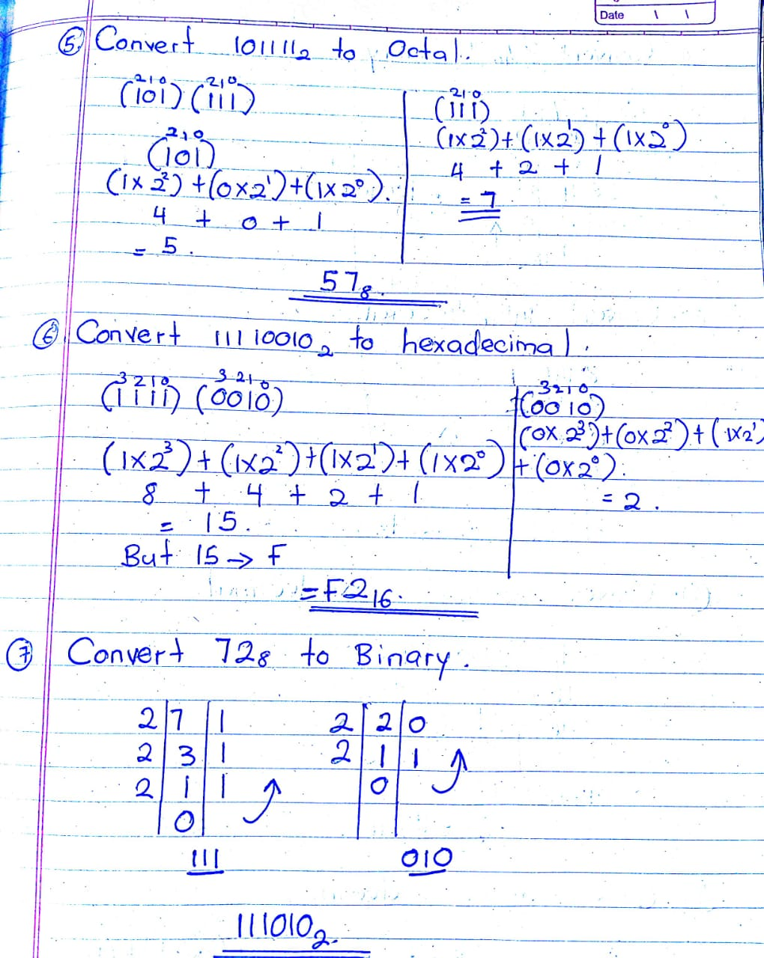
B.2 Practical conversion activities
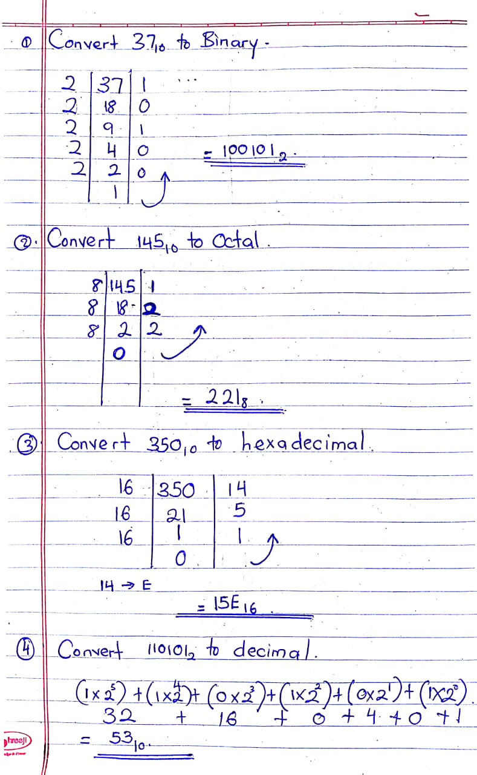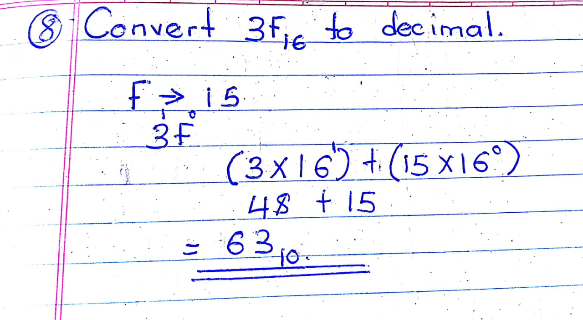

C.3. Investigate how data representation is applied in modern computing systems.

- Mobile phones
Phones use binary data to run apps, send messages, make calls and store photos and videos. All user inputs are converted into binary for processing.
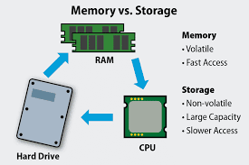
- Computer memory and storage

Computers store data in binary form using bits and bytes. RAM and storage devices save programs, files, and documents as binary numbers.
- Internet communication.
Data sent over the internet is converted into binary and transmitted in packets between devices through networks.
- Digital images.

Digital images are made of pixels. Each pixel is represented by binary values that determine its colour and brightness.
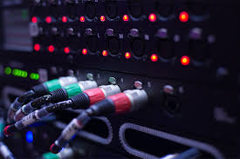
- Audio and video systems.
Audio and video files are stored and processed in binary form. Sound and video are converted into digital signals for recording and playback.

D.4. Why is hexadecimal preferred over long binary numbers in networking and programming?
- Hexadecimal is preferred because it is shorter and easier to read than long binary numbers. It helps programmers and network engineers work faster and reduces error.

What challenges would raise if computers used decimal internally instead of binary.?
- If computers used decimal internally instead of binary, the hardware would become more complex and slower.

How does understanding number systems help IT profession in networking, cyber security and programming?
- Understanding number system helps IT professionals in programming, networking and cyber security because computers store and process data using binary, hexadecimal, and decimal systems. It helps in coding, IP addressing, memory management, and data security.
Red Light | Yellow Light | Green Light | Binary
ON | OFF | OFF | 1,0,0
OFF | ON | OFF | 0,1,0
OFF | OFF | ON | 0,0,1

9. Why is hexadecimal preferred over long binary numbers in networking and programming?
Hexadecimal is shorter and easier to read.
Reduces errors when writing binary

10. What challenges would arise if computers used decimal internally instead of binary?
Hardware would become more complicated, slower, and less reliable.

11. How does understanding number systems help IT professionals in networking, cybersecurity, and programming?
It helps professionals understand networking, memory systems, programming, cybersecurity, and troubleshooting.

REFERENCE:
Chapter 10: Computer Organisation Architecture page number 357
Computer systems: A programmer’s Perspective by Bryant and O’Halloran

